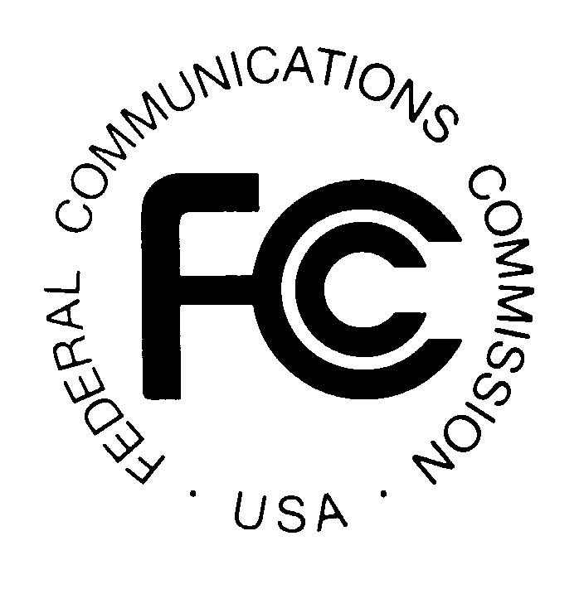PUBLIC NOTICE

News media information 202 / 418-0500
Fax-On-Demand 202 / 418-2830
TTY 202 / 418-2555
Internet: http://www.fcc.gov
ftp.fcc.gov

Federal Communications Commission
445 12th St., S.W.
Washington, D.C. 20554

REPORT NO: 0142 SPECIAL RELIEF AND SHOW CAUSE PETITIONS April 25, 2005

Portions of this Public Notice have been produced by the Media Bureau’s computer-based Data Management systems.
This Public Notice is intended to list only special relief requests, petitions for order to show cause and related petitions for reconsideration
or applications for review. CSR (cable special relief) petitions and CSC (cable show cause) petitions refer to cable-related matters pursuant
to Part 76. The newly-designated BSR (broadcast special relief) petitions refer to certain non-application-related broadcast matters pursuant
to Part 73.

Parties seeking special relief pursuant to Part 76 are advised that such requests must be initiated through the special relief provisions of
Section 76.7 of the Rules. Many of these filings are subject to the pleading cycle rules set forth in Section 76.7, while others have their
own pleading cycle relative to the particular rule involved. For BSR petitions filed pursuant to Part 73, the pleading cycle
will be the same as that mandated by Section 76.7 unless stated otherwise.

Please note that petitions for reconsideration and applications for review are listed for informational purposes only. The applicable pleading cycles for these types of petitions are found in Sections 1.106 and 1.115 of the Commission’s rules, respectively.

Files containing these petitions can be reviewed in the Commissions Reference Information Center, CY-Level, 445 12th Street, SW Washington, DC 20554. The letter code following a CSR Number refers to the particular subject of the petition. Those currently in use are: A – ADI/DMA; M – must carry; E – effective competition; C – retransmission consent; P – program access; R – rate regulation; F – rate freeze; L – commercial leased access;
Z – technical; S – significantly viewed; N – nonduplication/syndicated exclusivity/sports deletion; D – small system definition; O – otard; and X – cross ownership. If no letter appears after the CSR number, the petition is considered to be in the miscellaneous category. CSC and BSR petitions do not
have letter code designations.

It is requested that all responses or statements refer to the file number assigned to the petition.

For further information about this Public Notice contact the Media Bureau at (202) 418-7200

REPORT NO: 0142 SPECIAL RELIEF AND SHOW CAUSE PETITIONS April 25, 2005

CSR Number Petitioner Respondent Special Relief Request Communities Code

CSR-6679-E MCC Georgia LLC Fitzgerald, GA No Code

CSR-6680-E MCC Georgia LLC Decatur, Donalsonville, Seminole, GA No Code

CSR-6681-A Time Warner Entertainment Co. L.P. KAIT(TV) Crittenden County, West Memphis, No Code
Marion, AR et al.

CSR-6682-E Mediacom Southeast LLC Gulf Breeze, FL No Code

CSR-6683-E Mediacom Southeast LLC Bay Minette, Daphne, Fairhope No Code
and Spanish Fort, AL

CSR-6684-E MCC Illinois LLC ("Mediacom") Clinton, Farmer City, Mahomet, and Melvin, IL No Code

CSR-6685-E Mediacom Southeast LLC Frisco City and Monroeville, AL No Code

CSR-6686-A Time Warner Entertainment EBC Buffalo, Inc. Cortland, Village of Homer, Rome, No Code
Advance/NewHouse Partnership Oswego, NY et al
d/b/a Time Warner Cable

CSR-6687-N Flint License Subsidiary Corp WXYZ-TV Flint, MI No Code
(WJRT(TV)

CSR-6688-E Charter Communications Auburn, MI No Code

CSR-6689-E Charter Communications Kawkawlin, MI No Code

CSR-6690-E Charter communications Kinross, MI No Code

CSR-6691-E Charter Communications Richfield, MI No Code

CSR-6692-E Charter Communications Rosebush, MI No Code

REPORT NO: 0142 SPECIAL RELIEF AND SHOW CAUSE PETITIONS April 25, 2005

CSR Number Petitioner Respondent Special Relief Request Communities Code

CSR-6693-E Charter Communications Thomas, MI No Code

CSR-6694-E Charter Communications Bellaire Village, Boyne, Cadillac, MI et al No Code

CSR-6695-E Charter Communications Cheboygan, MI No Code

CSR-6696-E Charter Communications McBain City, MI No Code

-FCC-

